LESSON 3.
Microbiology diagnosis of intestinal bacterial diseases (escherichiosis, salmonellosis, enteric fever)

LESSON PLAN:
• Morpho-biological characteristics of intestinal bacteria. Antigen structure, serological classification and serotypes.
• Intestinal bacteria as a representative of the normal microflora of the human body and as a typical conditionally pathogenic bacteria
• Groups of enteropathogenic intestinal bacteria
• Pathogenesis and clinical manifestations of diseases caused by intestinal bacteria,
• Antibiotic-resistant forms of intestinal bacteria. Broad-spectrum beta-lactamase-resistant bacteria.
• Microbiological diagnosis of diseases caused by intestinal bacteria
• General characteristics of Salmonella, its intestinal and paratyphic agents, their morpho-biological characteristics. Antigen properties and classification.
• Pathogenesis of the abdominal cavity.
• Microbiological diagnostics of the abdominal cavity: bacteriological and serological (Vidal reaction and IFA). Determination of bacterial transportability
• Specific treatment and prevention of abdominal pain.
• Salmonella as a causative agent of food poisoning and nosocomial infections.
• Microbiological diagnosis of salmonellosis

Enterobacteriaceae
ESCHERICHIA COLI
Trigger Words
Gastroenteritis, EAEC, EIEC, EPEC, ETEC, STEC, neonatal meningitis, urinary tract infection

Biology and Virulence
Gram-negative, facultative anaerobic rods
Fermenter; oxidase negative
Lipopolysaccharide consists of outer somatic O polysaccharide, core polysaccharide (common antigen), and lipid A (endotoxin)

Epidemiology
Most common aerobic gram-negative rods in the gastrointestinal tract
Most infections are endogenous (patient’s microbial flora), although strains causing gastroenteritis are generally acquired exogenously

Diagnosis
ᑏᑏOrganisms grow rapidly on most culture media
ᑏᑏ Enteric multiplex NAATs considered gold standard diagnostic

Diseases
At least five different pathogenic groups cause gastroenteritis: EAEC, EIEC, EPEC, ETEC, and STEC
Most cause diseases in developing countries, although STEC is an important cause of hemorrhagic colitis and hemolytic uremic syndrome
Extraintestinal disease includes bacteremia, neonatal meningitis, urinary tract infections, and intraabdominal infections

Treatment, Prevention, and Control
Enteric pathogens are treated symptomatically unless disseminated disease occurs
Antibiotic therapy is guided by in vitro susceptibility tests; increased resistance to penicillins and cephalosporins mediated by ESBLs
Appropriate infection-control practices are used to reduce the risk of nosocomial infections (e.g., restricting use of antibiotics, avoiding unnecessary use of urinary tract catheters)
Maintenance of high hygienic standards to reduce the risk of exposure to gastroenteritis strains
Proper cooking of beef products to reduce risk of STEC infections

SALMONELLA
Trigger Words Gastroenteritis, enteric fever, antibiotic treatment

Biology and Virulence
Gram-negative, facultative anaerobic rods
Fermenter; oxidase negative
Lipopolysaccharide consists of outer somatic O polysaccharide, core polysaccharide (common antigen), and lipid A (endotoxin)
More than 2500 O serotypes
Virulence: refer to Box 25.2; tolerant of acids in phagocytic vesicles
Can survive in macrophages and spread from the intestine to other body sites

Epidemiology
Most infections are acquired by eating contaminated food products (poultry, eggs, and dairy products are the most common sources of infection)
Direct fecal-oral spread in children
Salmonella Typhi and Salmonella Paratyphi are strict human pathogens (no other reservoirs); these infections are passed person to person; asymptomatic long-term colonization occurs commonly
Individuals at risk for infection include those who eat improperly cooked poultry or eggs, patients with reduced gastric acid levels, and immunocompromised patients
Infections occur worldwide, particularly in the warm months of the year

Diseases
Diseases: enteritis (fever, nausea, vomiting, bloody or nonbloody diarrhea, abdominal cramps); enteric fever (typhoid fever,
paratyphoid fever); bacteremia (most commonly seen with Salmonella serotype Typhi, Salmonella serotype Paratyphi, Salmonella serotype Choleraesuis); asymptomatic colonization (primarily with Salmonella Typhi and Salmonella Paratyphi)

Clinical Diseases Induced by Salmonellae
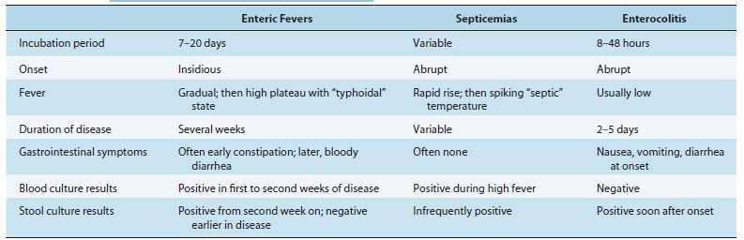

Diagnosis
ᑏᑏ Isolation from stool specimens requires use of selective media
ᑏᑏ Enteric multiplex NAATs considered gold standard diagnostic

Treatment, Prevention, and Control
Antibiotic treatment not recommended for enteritis because this may prolong the duration of disease
Infections with Salmonella Typhi and Salmonella Paratyphi or disseminated infections with other organisms should be treated with an effective antibiotic (selected by in vitro susceptibility tests); fluoroquinolones (e.g., ciprofloxacin), chloramphenicol, trimethoprim sulfamethoxazole, or a broad-spectrum cephalosporin may be used
Most infections can be controlled by proper preparation of poultry and eggs (completely cooked) and avoidance of contamination of other foods with uncooked poultry products
Carriers of Salmonella Typhi and Salmonella Paratyphi should be identified and treated
Vaccination against Salmonella Typhi can reduce the risk of disease for travelers into endemic areas

EAEC, Enteroaggregative E. coli; EIEC, enteroinvasive E. coli; EPEC, enteropathogenic E. coli; ESBL, extended-spectrum _-lactamase; ETEC, enterotoxigenic E. coli; NAAT, nucleic acid amplification test; STEC, Shiga toxin–producing E. coli.

Important Enterobacteriaceae
Organism Historical Derivation
Escherichia coli - escherichia, named after Escherich; coli, of the colon
Salmonella enterica - salmonella, named after Salmon; enteron, gut; pertaining to the gut
Salmonella Typhi - typhi, of typhoid; disease is typhoid fever
Salmonella Paratyphi - paratyphi, of a typhoid-like infection
Salmonella Choleraesuis - cholera, cholera; sus, hog; cholera of a hog
Salmonella Typhimurium - typhi, of typhoid; murium, of mice; typhimurium, typhoid of mice
Salmonella Enteritidis - enteris, gut; idis, inflammation
Shigella dysenteriae - shigella, named after Shiga; dysenteriae, dysentery
S. flexneri - flexneri, named after Flexner
S. boydii - boydii, named after Boyd
S. sonnei - sonnei, named after Sonne
Yersinia pestis - yersinia, named after Yersin; pestis, plague
Y. enterocolitica - enterocolitica, pertaining to the intestine and colon
Y. pseudotuberculosis - tuberculum, a small swelling; pseudotuberculosis, false swelling
Common Medically Important Enterobacteriaceae
Citrobacter freundii, C. koseri
Enterobacter cloacae
Escherichia coli
Klebsiella pneumoniae, K. oxytoca
Morganella morganii
Proteus mirabilis
Salmonella serotype Typhi, Salmonella nontyphoidal serotypes
Serratia marcescens
Shigella sonnei, S. flexneri
Yersinia pestis, Y. enterocolitica, Y. Pseudotuberculosis
Common Virulence Factors Associated with Enterobacteriaceae
Endotoxin
Capsule
Antigenic phase variation
Type III secretion systems
Sequestration of growth factors
Resistance to serum killing
Antimicrobial resistance

Specialized Virulence Factors Associated with Escherichia coli
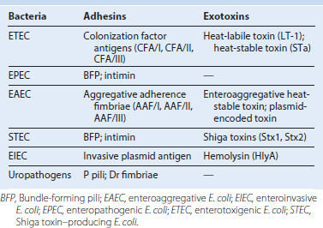
Gastroenteritis Caused by Escherichia coli
